Deploying the application to Azure using Vscode

Create a Deployment Package
Step 1 − Go to code in Visual Studio.
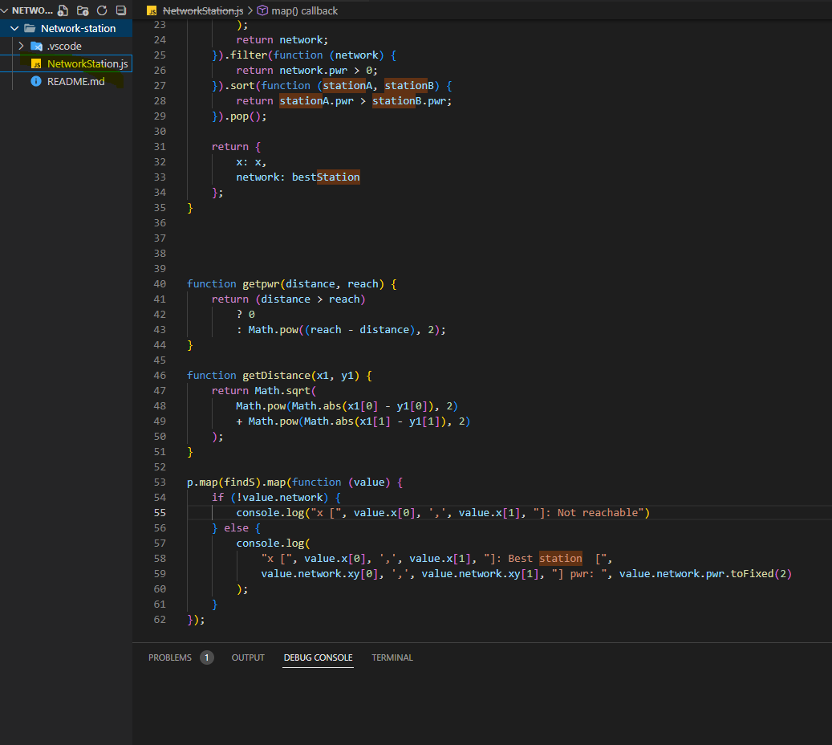

Step 2 − Right-click on the name of the application in the solution explorer. Select ‘Publish’.

Create Deployment Package
Step 3 − Create a new profile by selecting ‘New Profile’ from the dropdown. Enter the name of the profile. There might be different options in dropdown depending on if the websites are published before from the same computer.

New Profile
Step 4 − On the next screen, choose ‘Web Deploy Package’ in Publish Method.

Web Deploy Package
Step 5 − Choose a path to store the deployment package. Enter the name of site and click Next.

MyWebProfile
Step 6 − On the next screen, leave the defaults on and select ‘publish’.

After it’s done, inside the folder in your chosen location, you will find a zip file which is what you need during deployment.

Create a Website in Azure using PowerShell
Step 1 − Enter the following cmdlets to create a website. Replace the highlighted part. This command is going to create a website in free subscription. You can change the subscription after the website is created.

New-AzureWebsite -name "NetworkStation" -location "East US"
Create Website PowerShell
If cmdlet is successful, you will see all the information as shown in the above image. You can see the URL of your website as in this example it is mydeploymentdemo.azurewebsites.net.

Step 2 − You can visit the URL to make sure everything has gone right.

Deploy Website using Deployment Package
Once the website is created in Azure, you just need to copy your website’s code. Create the zip folder (deployment package) in your local computer.

Step 1 − Enter the following cmdlets to deploy your website.

Publish-NetworkStationProject -name "Netwokstation" -package
"D:\Users\mohammed\NetworkStation \NStation.zip"
Here in above commandlet, the name of the website just created is given and the path of the zip file on the computer.

Step 2 − Go to networkstation.azurewebsites.net

